**Summary of Percentile**

**Result: -**

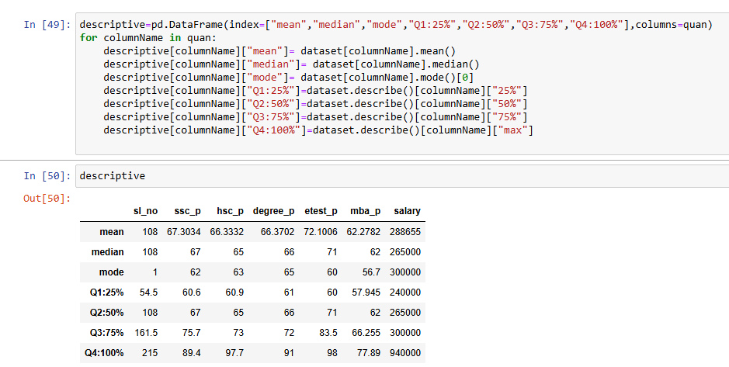

**Description for Quartiles (Q1, Q2, Q3, Q4):**

This table presents a **statistical summary** of various academic and employment-related metrics, including **SSC percentage, HSC percentage, Degree percentage, Employability test scores, MBA percentage, and Salary**.

* **Q1 (25%):** 25% of the values fall below this level. **For salary, Q1 is 240,000**.
* **Q2 (50% / Median):** The middle value (**265,000 for salary**).
* **Q3 (75%):** 75% of values fall below this level. **For salary, Q3 is 300,000**.
* **Q4 (100% / Max):** The highest recorded value. **For salary, the maximum is 940,000.**